Great Recession
Great Depression
Harmon/Econ: Unit 5 Name:____________________________Period:______
Comparing the Great Depression to the Great Recession Venn Diagram
- What’s the main difference between a recession and a depression? ______________________________________________________________________
_________________________________________________________________________________________________________________________________
- How was the Great Recession different from other recessions? _________________________________________________________________________
_________________________________________________________________________________________________________________________________
Harmon/Econ Unit 5
Business Cycles

Label the business cycle graph below. Include the following:
-Expansion -Peak -Trough
-Recession -Trend Line
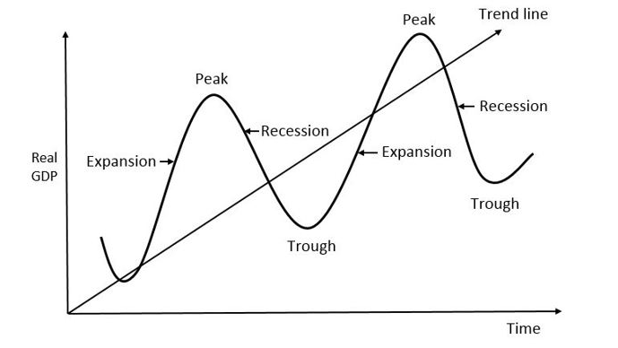
- How long does it take for the government to announce that there is a recession? ______________________________________________________
_____________________________________________________________________________________________________________________________
- What does a trough indicate? _________________________________________________________________________________________________
- Why are ups and downs in the business cycle normal? _____________________________________________________________________________
_____________________________________________________________________________________________________________________________

