Here’s How Third-Party Candidates Have Changed Elections
America’s two-party political system makes it difficult for candidates from outside the Republican and Democratic parties to win presidential elections.

By Christopher Klein

America’s two-party political system makes it difficult for candidates from outside the Republican and Democratic parties to win presidential elections. Since 1920, in fact, only three third-party candidates—Robert La Follette in 1924, Strom Thurmond in 1948 and George Wallace in 1968—have been able to win even a single electoral vote. That doesn’t mean, however, that third-party candidates haven’t altered the outcomes of presidential elections over the course of American history.

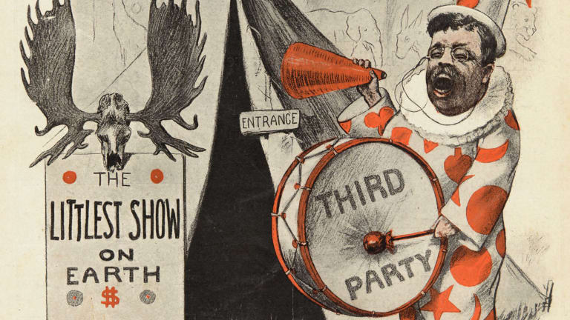
1912—William Taft vs. Woodrow Wilson
Theodore Roosevelt challenges the sitting president and creates the Progressive Party.
The title for highest share of votes ever earned by a third-party candidate in American history is still held by Theodore Roosevelt during the election of 1912.
After serving nearly two full terms in the White House, President Theodore Roosevelt opted not to break tradition and run for a third term in 1908. But, when Roosevelt’s close friend and hand-picked successor, William Howard Taft, failed to advance his reform-minded agenda during his first term, Roosevelt challenged the sitting president for the 1912 Republican Party nomination.
Although Roosevelt overwhelmingly won the most votes during the primaries, the Republican National Convention nominated the more conservative Taft to stand for re-election. A bitter Roosevelt broke with the GOP to form the Progressive Party, nicknamed the “Bull Moose Party” because Roosevelt often declared himself “fit as a bull moose.” The party advocated the direct election of U.S. senators, women’s suffrage, tariff reductions and social reforms.
Roosevelt and Taft ended up splitting the Republican vote, which led to an easy victory by Democratic nominee Woodrow Wilson. Roosevelt finished in second after winning six states and 27 percent of the popular vote. Taft was a distant third followed by another third-party candidate, Eugene V. Debs. The Socialist Party nominee received nearly one million votes in the fourth of his five bids for the White House.
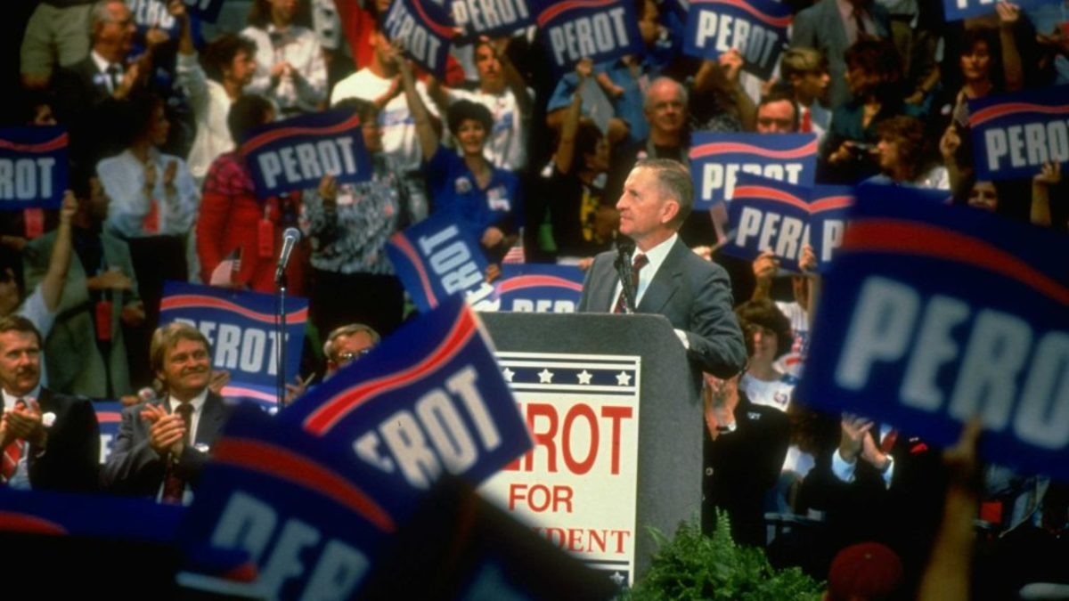
Texas billionaire Ross Perot surrounded by a sign-waving crowd of supporters at his presidential campaign rally. (Credit: Shelly Katz/The LIFE Images Collection/Getty Images)
1992—George H. Bush vs. Bill Clinton
Independent Ross Perot throws his hat into the ring, takes it back and then throws it again.
After supporters gathered enough signatures to place him on the ballot in every state, Texas billionaire H. Ross Perot surged to the top of the polls in the spring of 1992. Advocating for a balanced federal budget, campaign finance reform and congressional term limits, Perot capitalized on low public support for President George H.W. Bush.
Despite his support, Perot made the sudden decision to drop out of the race in July 1992, saying that he no longer believed he could win the presidency with the improving performance of Democratic nominee Bill Clinton. He later said the decision was based on his belief that the Bush campaign planned to spread rumors about his daughter and sabotage her impending wedding. Weeks before Election Day, Perot made the equally surprising announcement that he was resuming his campaign. The independent candidate’s poll numbers remained high enough to permit his inclusion in the presidential debates with Bush and Clinton.
With his folksy manner and half-hour infomercials on broadcast networks, Perot received 19 percent of the vote, compared to 43 percent for Clinton and 37 percent for Bush. Some Bush campaign officials believed Perot spoiled Bush’s re-election by drawing more votes from Republicans than Democrats. However, in a one-on-one contest, Clinton consistently led Bush in public polling from the summer of 1992 onwards. According to an analysis of the second choices of Perot supporters conducted by Voter Research & Surveys for major news organizations, Perot’s third-party run did not alter the outcome of the election. One national exit poll found that Clinton would have beaten Bush by a half-million more votes had Perot not been on the ballot.
In 1996, Perot made a repeat bid for the White House as a candidate for the Reform Party, which he established a year earlier. In that election against Clinton and Republican Bob Dole, Perot garnered just over 8 percent of the popular vote.
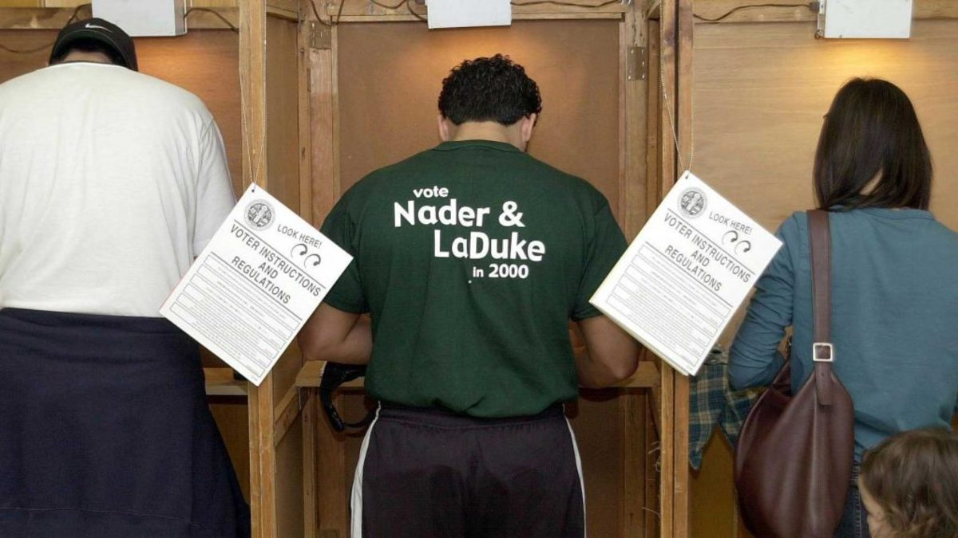
A man wearing a t-shirt supporting Green Party presidential candidate Ralph Nader at the polling statio, 2000. (Credit: Vince Bucci/AFP/Getty Images)
2000—Al Gore vs. George W. Bush
Ralph Nader and the Green party earn votes, but it all comes down to Florida.
The election was so tight that it took a 36-day legal battle and a controversial 5-4 Supreme Court ruling before Al Gore conceded, although he won the national popular vote by more than a half-million votes.
The race not only centered on the candidates from the Democratic and Republican parties, Al Gore and George W. Bush, but on third-time presidential candidate Ralph Nader. An American lawyer, political activist and consumer advocate Nader was Green Party candidate.
Nader hoped to earn 5 percent of the popular vote, which would have given his party access to federal matching funds in the following presidential election. Nader fell short of his goal, receiving 2.9 million votes and less than 3 percent of the popular vote. However, some believe Nader’s third-party candidacy siphoned enough votes from the Democratic nominee, Vice President Al Gore, to swing the victory to Republican George W. Bush.
The difference was Florida, which Bush won by fewer than 600 votes to give him a 271-to-266 Electoral College edge. Had even a small percentage of the nearly 100,000 votes garnered by Nader in Florida shifted to Gore, the Democratic candidate would have won the election. In addition, the 22,000 votes won by Nader in New Hampshire were three times the size of Bush’s margin of victory in that state. If New Hampshire had flipped to Gore, that too would have given him the victory.
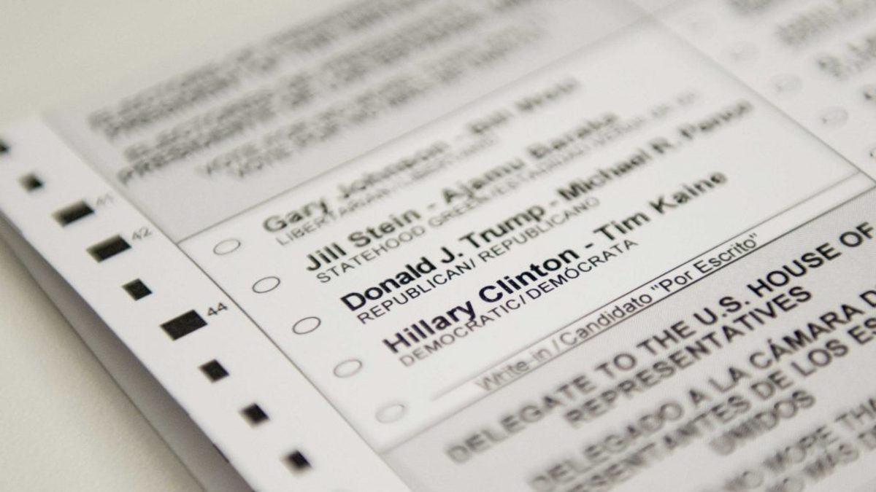
An absentee ballot featuring voting options for the 2016 US presidential election. (Credit: Saul Loeb/AFP/Getty Images)
2016—Hillary Clinton vs. Donald Trump
When outsiders dominated the presidential campaign.
From Donald Trump to Bernie Sanders to Gary Johnson to Jill Stein, political outsiders dominated the 2016 presidential campaign from its outset. But they weren’t just running on third party tickets.
Not only did businessman and political novice Donald Trump surge to the Republican nomination, Vermont’s Bernie Sanders, a self-described democratic socialist who served as an independent in the Senate, received 46 percent of pledged delegates during the primary campaign for the Democratic nomination.
With Trump and Democratic nominee Hillary Clinton both suffering low approval numbers, third-party candidates received considerable attention throughout the campaign. Running on the Libertarian ticket for the second successive campaign, former New Mexico Governor Gary Johnson received nearly 4.5 million votes, which accounted for just over 3 percent of the popular vote. That was the best third-party candidate performance since Perot. Green Party nominee and Massachusetts physician Jill Stein, also running in her second consecutive presidential election, made an appeal to disaffected Sanders supporters and earned just under 1.5 million votes. In addition, independent Evan McMullin appeared on the ballot in 11 states and received over 700,000 votes, including more than 20 percent of the vote in his native state of Utah.
According to some political analysts, third-party candidates aided Trump’s election. They pointed to the results in Michigan, Pennsylvania and Wisconsin, where Stein’s vote total exceeded Trump’s margin of victory. Had Stein’s votes in those three states flipped to Clinton, she would have won the Electoral College in addition to her popular vote majority. However, according to Politico, Stein has rejected the claim by pointing to exit polls that not only showed the majority of her voters would have stayed home instead of casting ballots for Clinton but that a sizable number of her supporters preferred Trump as a second choice.

