Final Review Study Guide

*Unit 1: Constitution*

1. According to Locke, what is the main purpose of government? What might happen if government is given too much power to do this?

2. Explain the idea of the Social Contract?

3. What is the rationale for Separation of Powers? Who came up with this idea?

4. What does each branch of the government do?
Legislative:
Executive:
Judicial:

5. What is the purpose of Checks and Balances?

6. Below is the chart of Checks and Balances that each branch has on each other.
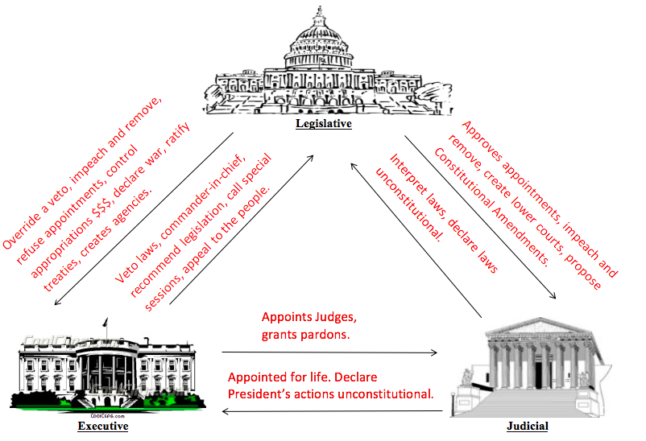

7. What was the main problem with the Articles of the Confederation

8. What was the Great Compromise?

9. What is Federalism?

10. What are Delegated powers?

11. What are Reserved powers?

12. What are Concurrent Powers?

13. Who were the Federalists (what did they support and why)?

14. Who were the Anti-federalists (what did they support and why)?

**Unit 2: Legislative Branch**

15. Why did the Framers of the Constitution choose a 2 house Congress? (historical, political, theoretical)

16. What are some of the advantages of the House members’ terms only being 2 years?

17. What are some of the advantages of the Senatorial terms being 6 years?

18. What are off-year (mid-term) elections? What often happens during off-year elections?

19. What is reapportionment, and how is it determined?

20. What 3 criteria must state legislatures follow when drawing congressional districts (redistricting)? What can’t they do when redistricting?

21. What is gerrymandering?

22. Why is the Speaker of the House the most important position in Congress? Who is the current Speaker of the House?

23. Who is President of the Senate (title)? What do they do?

24. What significant role do committees play in congress?

25. What is a filibuster?

26. What is a rider?

***Unit 3: Presidential Powers & Executive Branch***

27. What are the formal qualification for the President?

28. What is the White House Staff?

29. What role do the following positions play?
National Security Advisor:

Press Secretary:

Chief of Staff:

30. What does “Balancing the Ticket” refer to when it comes to selecting Presidential running mates?

31 What does the Constitution say about who has the power to take America to war?

32. What is the War Powers Act? Identify key aspects.

33. What 4 things can a President do when Congress sends him a bill?
1. 2.
3. 4.

39. How do presidents use the threat of a veto?

40. Who has the power of impeachment? How many needed to impeach?

41. Who has the power to try impeachments and removal? How many needed?

42. Who presides over a presidential impeachment trial?

43. For what types of crimes or offenses can a president be impeached?

44. What is Executive Privilege?

45. How did Executive Privilege come into question during the Watergate investigation?

46. How did U.S. vs. Nixon both strengthen and weaken the power of Executive privilege?

****Unit 4: Political Parties & Elections****

47. What is a political party? How are the American parties different than parties in most other nations?

48. What is the Party in Power?

49. What role does the party out of power play?

50. Why do we have a two-party system in the U.S.?

51. What is a Party Platform?

52. Be familiar with each party’s stance on major issues. Environment (drilling), abortion, taxes, immigration, gun control

53. What are caucuses and primaries?

54. What are some of the criticisms of the first caucuses and primaries being held in Iowa and New Hampshire?

55. What is the Electoral College? Why was it first created? What are some of the criticisms of this system?

56. Why it would be difficult to get rid of the Electoral College System.

*****Unit 5: Judicial Branch*****

57. What is Jurisdiction?

58. What is original jurisdiction?

59. What is appellate jurisdiction?

60. What is a plaintiff?

61. What is a defendant?

62. What is criminal law?

63. Who is the plaintiff in a criminal trial?

64. What is civil law?

65. What is generally the “punishment” in civil trials?

66. What is common law?

67. What does a Grand Jury do?

68. What is an indictment?

69. What are two advantages of using grand juries?

70. What is a felony? Misdemeanor?

71. What is an injunction? What is its purpose?

72. What is Judicial Review?
73. How did Marbury v. Madison established Judicial Review?

74. Understand Civil vs. Criminal scenarios.

******Unit 6: Rights of the Accused******

75. Why did Miranda claim his rights were violated?

76. Why did the State of Arizona believe Miranda’s rights were not violated?

77. What Constitutional Rights did Clarence Gideon claim had been violated?

78. What did the Supreme Court rule in Gideon v. Wainwright?

79. Explain the protections spelled out in the 5th Amendment.
- -
- -
80. Explain the protections spelled out in the 6th Amendment.
- - -
- - -
81. What did the Supreme Court rule in the In Re Gault case?

82. What is a search warrant? List the requirements that must be met in order for a judge to issue a warrant.

83. What is probable cause? How do judges determine if it exists?

84. What is the “totality of circumstances” when it comes to search warrants?

85. Know the list of situations in which a search might be permitted without a warrant.

86. What is the Exclusionary Rule?

87. In New Jersey v. T.L.O., what did the Supreme Court say about the 4th Amendment and unreasonable search and seizure in schools?

88. What did the Supreme Court say about school searches in Safford Unified School District #1 v. Redding?

