(Key) U.S. Government: Election Process & the Electoral College
Election Process:
- Candidate: Per Article 2, Section 1: natural born citizen, at least 35 years old, & U.S. resident for at least 14 years.
- Primary or Caucus:
  - Primary: state wide voting where voters use a secret ballot to cast their vote (New Hampshire 1st)
    - Open= voters can vote in the primary of either party. (Texas)
    - Closed= voters can only vote with the party they are registered with.
  - Caucus: informal local gathering where voters openly select delegates (Iowa 1st)
- National Convention:
  - Delegates travel to the convention to cast their vote to determine the party nominee.
  - The party nominee then selects their running mate (Vice President).
- General Election
  - Nominees selected by each party convention go head to head.
  - The goal is to win 270 of the 538 electoral votes.
- Incumbent: Name recognition, proves winner/leader, easier time raising money, build relationships by working with constituents, bring “pork” projects home to constituents.
- Challenger: anti-incumbency sentiment, unproven leader, risk for campaign donors, fresh view on the issues.

Campaign Finance:
- Candidates need money to get their message out to the public, achieve name recognition, combat negative ads being run by their opponent, pay campaign staff.
- How do candidates get money?
- Individual donations, Political parties, Interest groups
Examples of Interest groups:
  - PACs: a type of organization that pools campaign contributions from members and donates those funds to campaign for or against candidates
  - 527 groups: tax exempt groups created primarily to influence the selection, nomination, election, appointment or defeat of candidates to federal, state or local public office.
  - 501C groups-tax exempt non-profit, supposed to be non-political; don’t have to divulge contributions or donors
- Citizens United (2010)-Supreme Court ruled corporate/union funding of independent political broadcasts in candidate elections cannot be limited under the 1st amendment
  - Super PACs:
    - Make no contributions to candidates or parties.
    - Spend money independently on elections to advocate for a specific candidate.
    - There are no limits or restrictions on the sources of funds that may be used for these expenditures.
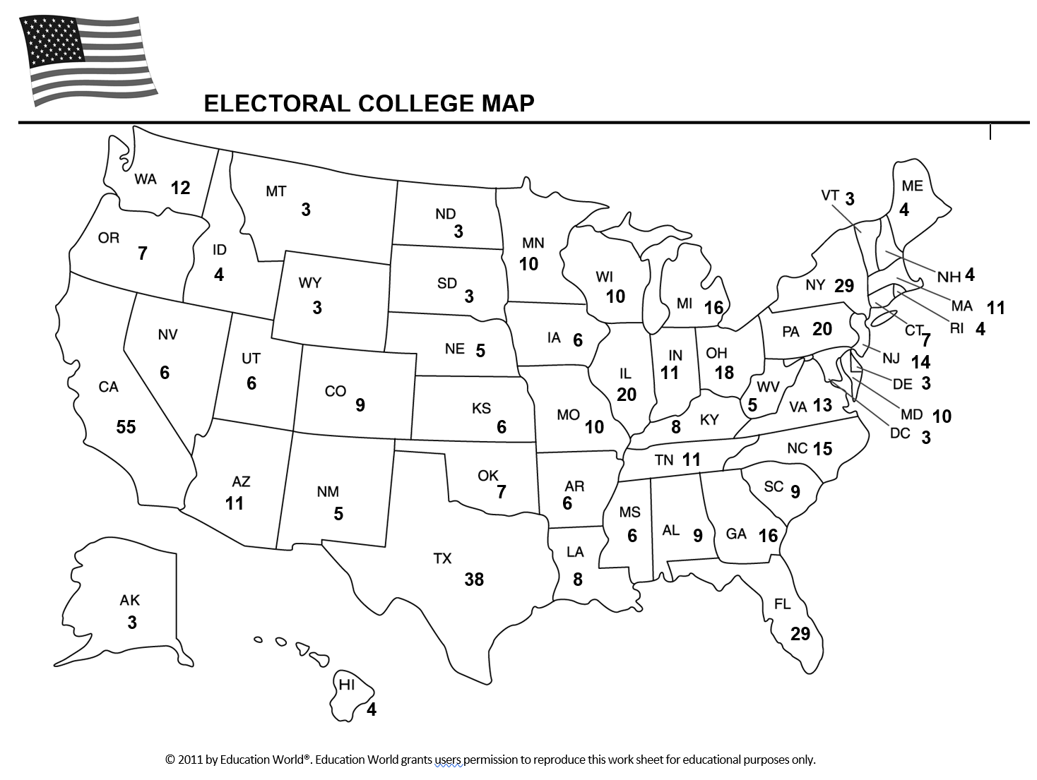

How many states can each usually party count on?
Democrats: _______
Republicans: ________
Battleground/Swing States: _______

Electoral College: Established by Article 2, Section 1 of the Constitution.
  - Founding Fathers wanted to the elite to have the final say.
  - Citizens do not directly elect the president or VP- we elect the electors.
  - Each state has as many votes as it does Representatives + Senators.
  - Winner-Take-All system- candidate that wins the popular vote in the state, wins all the states electors; exceptions are Maine & Nebraska which use a tiered system
  - Pres./VP ticket must win 270 out of 538 available electors (535 + 3 from D.C= 538)
  - If no candidate gets a majority (270 votes), the House of Representatives votes for president, with each state casting one vote (12th amendment) and the Senate votes for VP, with each senator casting 1 vote
Timeline
1. November- vote for President
2. December- Electors go to State Capital to cast ballots for P/VP
3. January- Electoral votes are counted by the sitting VP, in a joint session of Congress
4. January 20th- Inauguration Day

