U.S. Government: Election Process & the Electoral College
Election Process:
- Candidate: Per Article 2, Section 1: ___________________, at least 35 years old, & U.S. resident for at least ______________
- Primary or Caucus:
  - ____________: state wide voting where voters use a secret ballot to cast their vote (______________ 1st)
    - Open= voters can vote in the primary of ______________. (Texas)
    - Closed= voters can only vote with the party they are ______________ with.
  - ___________: informal local gathering where voters openly select delegates (_________ 1st)
- National Convention:
  - Delegates travel to the convention to cast their vote to _____________the party nominee.
  - The party nominee then selects their ______________ (Vice President).
- General Election
  - Nominees selected by each party convention go head to head.
  - The goal is to __________ of the 538 electoral votes.
- Incumbent: _______________, proves winner/leader, easier time raising money, build relationships by working with constituents, bring “pork” projects home to constituents.
- Challenger: anti-incumbency sentiment, _________________, risk for campaign donors, fresh view on the issues.

Campaign Finance:
- Candidates need _________ to get their message out to the public, achieve name recognition, combat negative ads being run by their opponent, pay campaign staff.
- How do candidates get money?
- Individual donations, Political parties, ______________
Examples of Interest groups:
  - PACs: a type of organization that pools ___________________ from members and donates those funds to campaign for or against candidates
  - 527 groups: tax exempt groups created primarily to _______________ the selection, nomination, election, appointment or defeat of candidates to federal, state or local public office.
  - 501C groups: tax exempt ____________, supposed to be non-political; don’t have to divulge contributions or donors
- Citizens United (2010)-________________ ruled corporate/union funding of independent political broadcasts in candidate elections _________________________ under the 1st amendment
  - Super PACs:
    - Make no ____________________ to candidates or parties.
    - Spend money independently on elections to advocate for a specific candidate.
    - There are no limits or restrictions on the sources of funds that may be used for these expenditures.

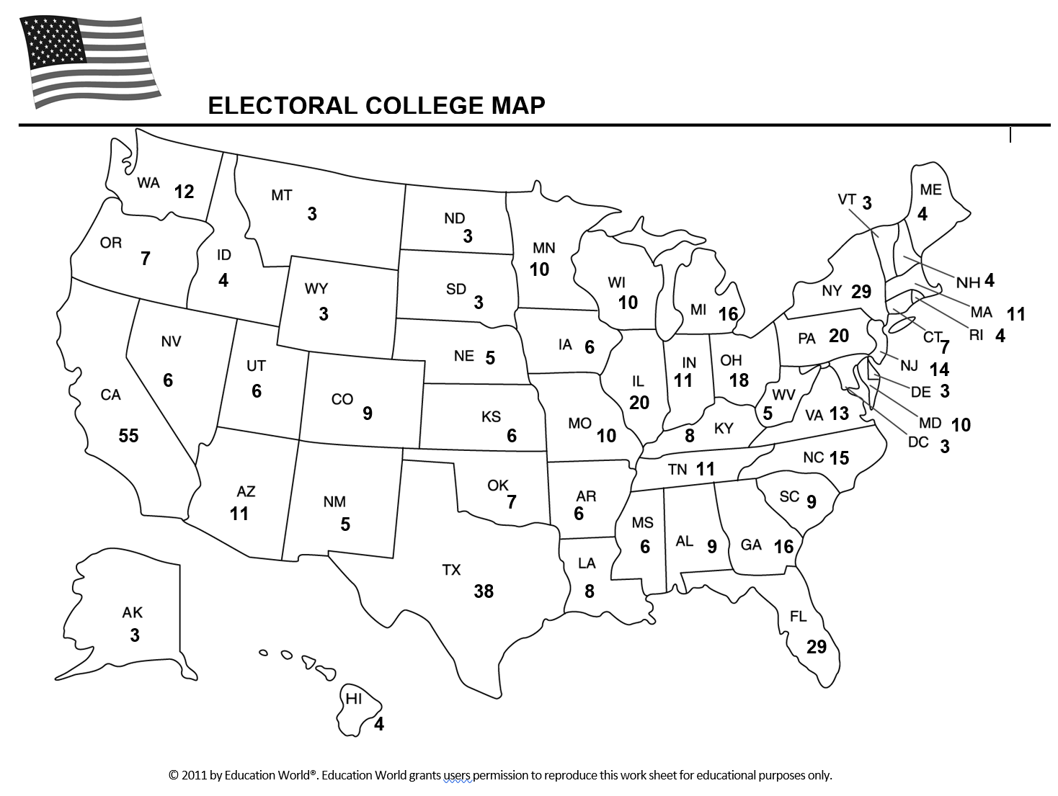
How many states can each party usually count on? (Color this on your map)
Democrats: _______
Republicans: ________
Battleground/Swing States: _______

Electoral College: Established by Article 2, Section 1 of the Constitution.
  - Founding Fathers wanted to the ________to have the final say.
  - Citizens do not directly elect the president or VP- ______________________.
  - Each state has as many votes as it does __________________________.
  - ________________________- candidate that wins the popular vote in the state, wins all the states electors; _______________ are Maine & Nebraska which use a tiered system
  - Pres./VP ticket must win _______ out of 538 available electors (535 + 3 from D.C= 538)
  - If no candidate gets a majority (270 votes), the _______________________ votes for _______________, with each state casting one vote (12th amendment) and the ____________votes for ______, with each senator casting 1 vote

Election Timeline
1. November- ______________________
2. December- __________________________ to cast ballots for P/VP
3. January- Electoral votes are __________________________, in a joint session of Congress
4. January 20th- _____________ Day

